**Virtual Device Creation**

**Step 1)** After installing Android SDK you will see the device and little android icon. When you click this icon, you will open android virtual device manager.

[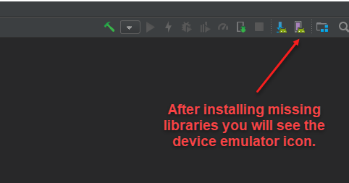](https://www.swtestacademy.com/wp-content/uploads/2018/01/device-emulator-icon-appeared.png)

**Step 2)** Let’s create a virtual device, Click to “**+ Create a Virtual Device**” button.

[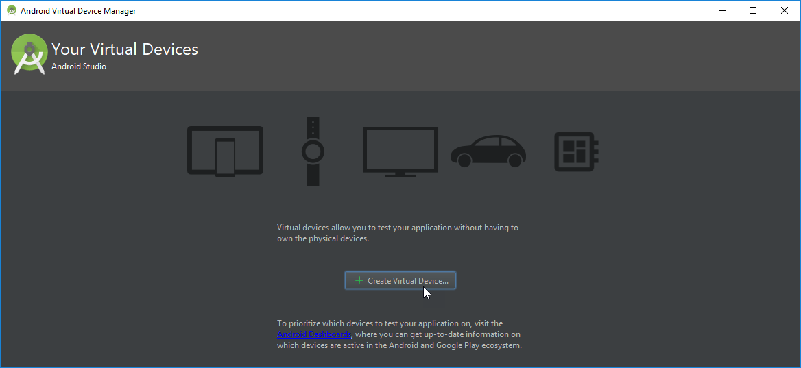](https://www.swtestacademy.com/wp-content/uploads/2018/01/create-a-virtual-device.png)

**Step 3)** Then, select a virtual device in the device list.

[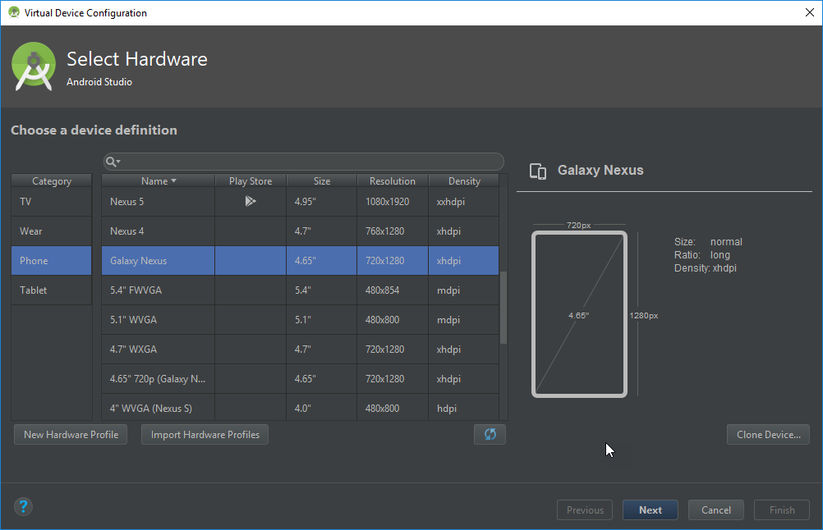](https://www.swtestacademy.com/wp-content/uploads/2018/01/create-a-virtual-device-2.png)

**Step 4)** I have selected Android 7.0. I have also a test device and its version is also 7.0 but you can select any of them. Click the download link and download the required libraries for selected version.

[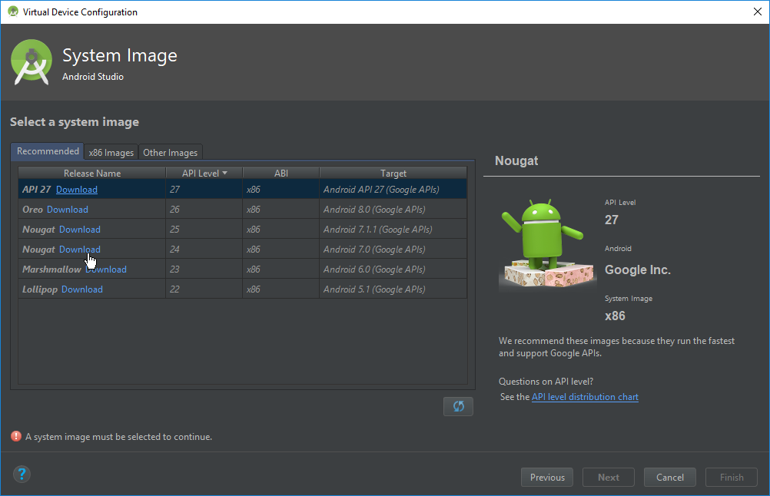](https://www.swtestacademy.com/wp-content/uploads/2018/01/create-a-virtual-device-3.png)

**Step 5)** After downloading the required libraries, click “next” to continue.

[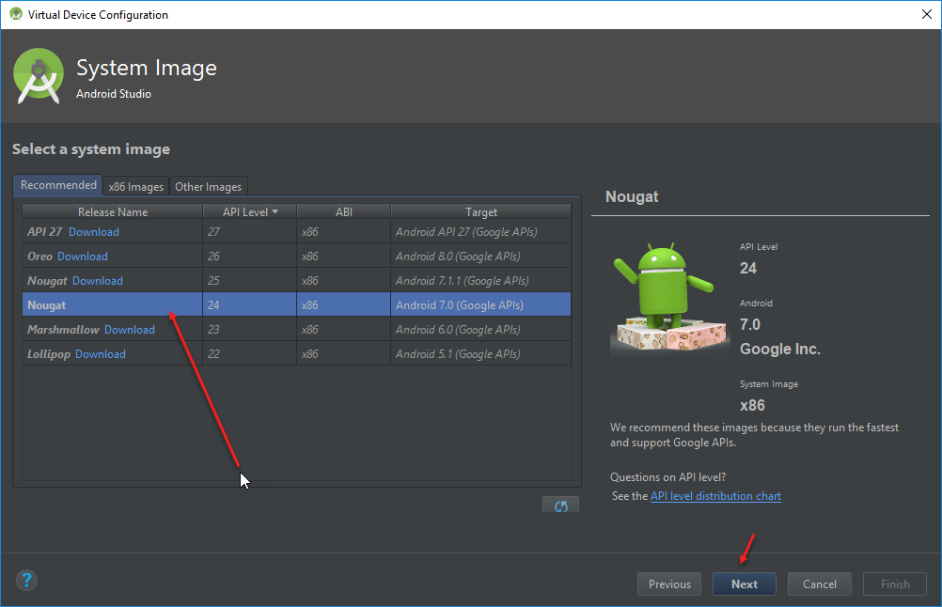](https://www.swtestacademy.com/wp-content/uploads/2018/01/create-a-virtual-device-4.png)

**Step 6)** Check the latest settings and give a name to your Android Virtual Device (AVD) and click Finish button.

[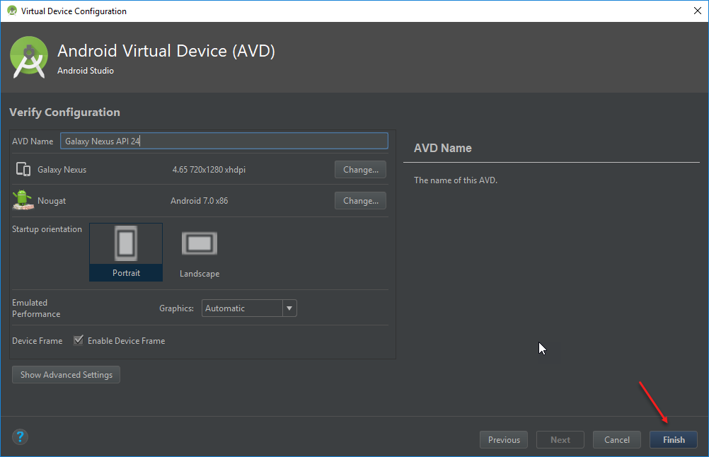](https://www.swtestacademy.com/wp-content/uploads/2018/01/create-a-virtual-device-5.png)

**Step 7)** Then, click the run icon and launch your device.

[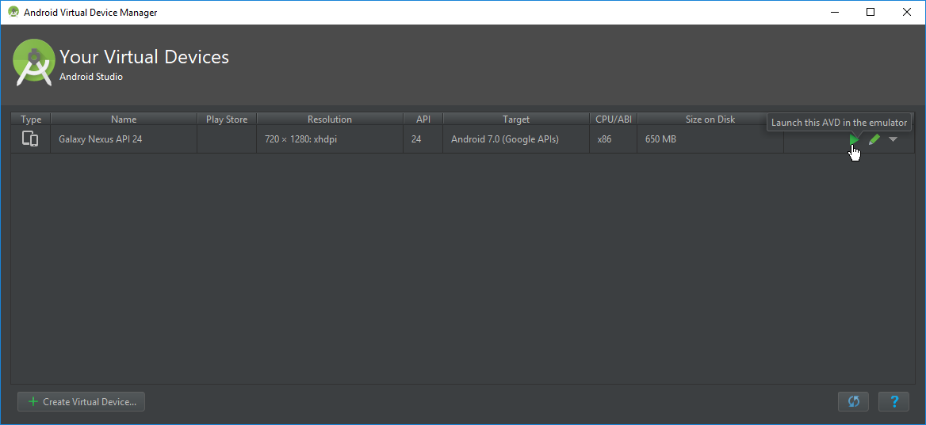](https://www.swtestacademy.com/wp-content/uploads/2018/01/launch-emulator-1.png)

**Step 8)** You will see the selected AVD on your screen as shown below.

[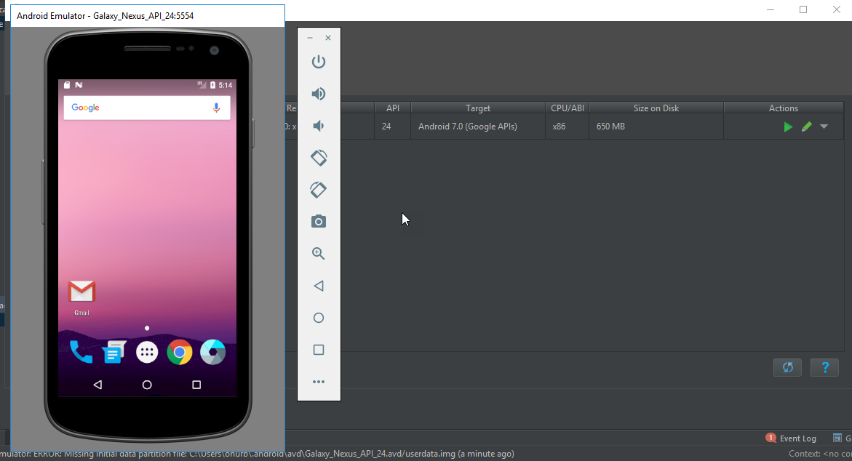](https://www.swtestacademy.com/wp-content/uploads/2018/01/launch-emulator-2.png)